ATM Safety Tips

*Written by Shiree Lind, Crime Prevention Specialist*

*Irvine Police Department, Crime Prevention Unit*

Many bank branches are closed under COVID-19, and people are using their ATM cards more than ever. To increase your safety and reduce your chances of becoming a crime victim, please review these crime prevention and awareness tips.

* When using the ATM be aware of your surroundings.
* Have your card out and ready to use.
* Choose a location that is easily seen.
* Check for card skimmers by wiggling the card reader.
* Cover your hand when entering your PIN.
* Look for any indications the device has been tampered with.
* Set up alerts with your bank for all transactions.
* Trust your instincts, if something doesn’t feel right go to another location.
* Use your grocery store for a cashback option.
* Avoid using the ATM during evening hours when it’s dark and no one else is around.
* Utilize your bank’s app to deposit checks and other transactions.

**What is a skimmer?**

A skimmer is a device used to capture your card numbers and PIN codes. Oftentimes it is an overlay that looks similar to the card reader or numeric pad that you use at the bank or gas station.

* Look for sticky residue and wiggle the card reader before using the machine.
* Look for pinhole cameras placed above the keypads on the ATM machine.

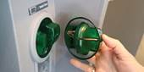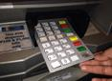

**What are shimmers?**

Like a skimmer, this device is used to read your card numbers. Instead of the device being placed on the outside it is typically placed inside a machine out of view, sometimes making the card difficult to insert. Be aware of this possibility and report any suspicions to your bank immediately.

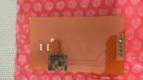

**PIN Pad skimmers**

Recently there have been skimmers placed over the PIN pads at checkout registers and self-checkout registers. Wiggle the PIN pad prior to inserting your card. Be aware of this possibility and report any suspicions to the business immediately.

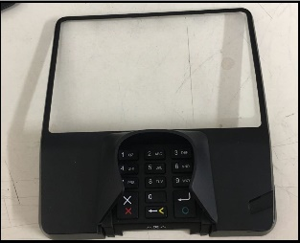

Report suspicious behavior to the bank or business affected. If you are a victim of a crime, please call the Irvine Police Department at 949-724-7000. If there are suspicious subjects on scene or to report a crime in progress, call 911.

Continue to be safe and aware of your surroundings.